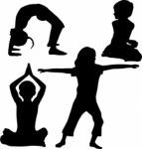

Kid’s Yoga

I love kids and kids love yoga-they are natural yoginis!

Available for Kindergarten and First Year Students

Instructor: Mrs. Russell
Child Light Yoga Certified

Thursdays: 3:15-4:00pm

Thursday classes
Sept. 20th, 27th
Oct. 4th, 11th,18th, 25th
Nov. 1st, 8th, 15th

Please wear comfortable clothing and supply a yoga mat
If your child is interested in participating in Yoga, please email me their name and teacher. mrussell@bcmcs.com

Payment: $50 to My School Account…click on Sept. 20th

Thank you!

